Due Date: Wednesday, April 23, 2020
Company, firm, etc. is LEGO

******Requirements:
- Answer 6 discussion Question
- Five (5- 10 Slide PP presentation)
- Include SWOT Analysis
- Include SEVEN (7) RATIOS of a financial report

Answer the following discussion question. The company is Lego.
If your firm is already engaged in international activities, answer the following questions:
1. | Is your company varying its product or service to adapt to differences in countries? Is the marketing approach different among the nations involved? Should it be?
2. | Is your firm working internationally to access larger markets? To gain low-cost input factors? To develop new competencies? Is its approach in all three areas appropriate?
3. | Which of the four global strategies is the firm using? Is this the best strategy for it to use? Why or why not? (Exhibit 10.8 provides a summary of the four global strategies.)

If your firm is not now engaged internationally, answer the following questions:
1. | Would your firm’s product or service need to be modified or marketed differently if it expanded beyond the home country?
2. | Does your firm have the potential to access larger markets by expanding internationally? Does it have the possibility of lowering input factors with such expansion? Please explain why or why not.
3. | If your firm decided to expand internationally, where does the firm reside on the integration-responsiveness framework? (Refer to Exhibit 10.6 if needed.) What does this result say about the “best” global strategy for your firm to use for international expansion?

~ Lego is the company for the PP Presentation…The guidelines to follow for the PPP is below.
~ Always exceed maximum standard
~ If more slides are need, Please refer to guidelines below.

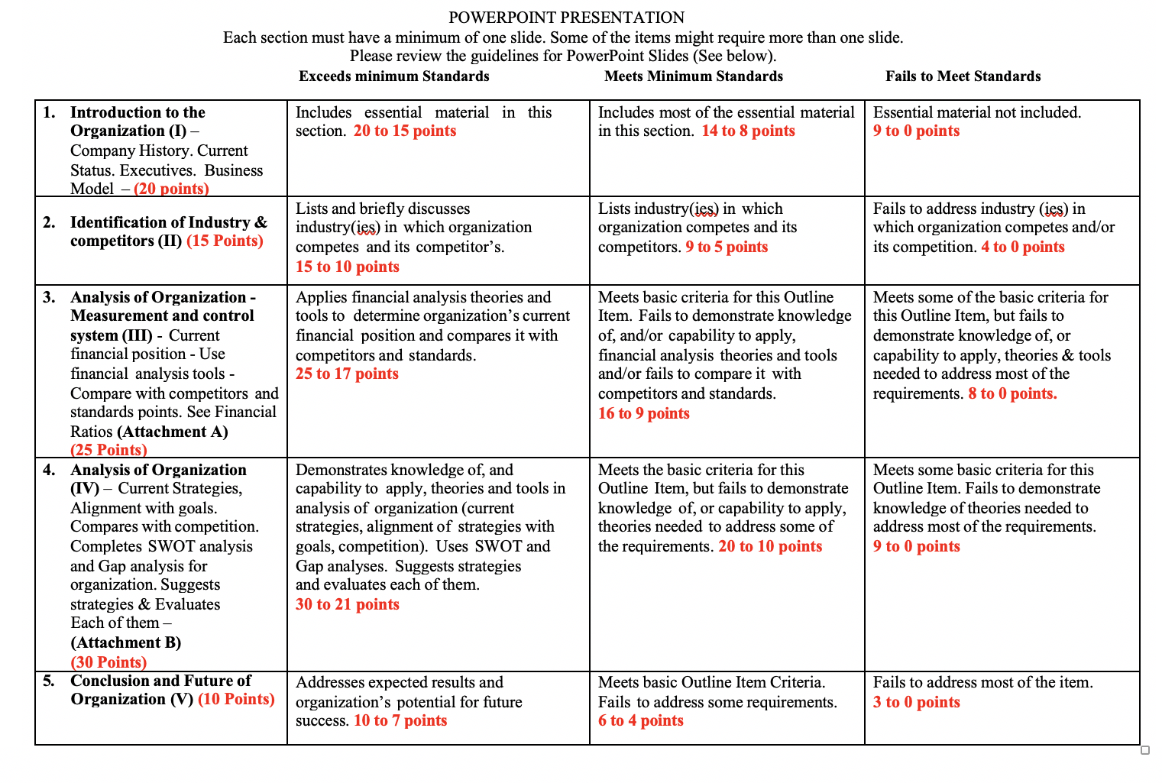

~ Guidelines for PP Presentation
~ Include Financial report ~ READING FINANCIAL REPORTS FOR PROFITABILITY RATIOS
MUST DO A TOTAL OF SEVEN (7) RATIOS Appendix A
~ Include SWOT analysis Appendix B

****See Below for additional information

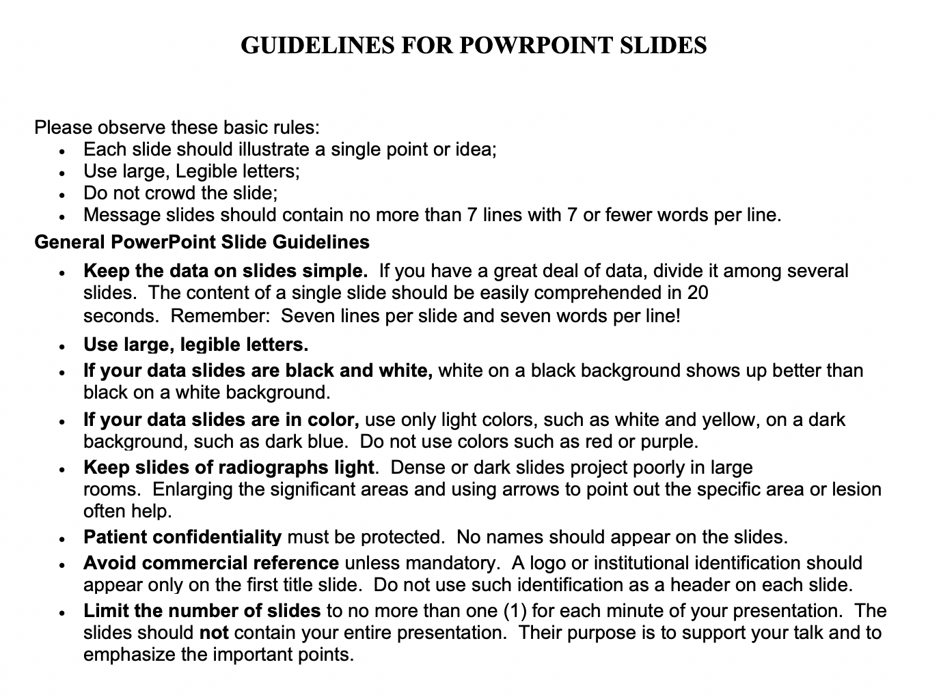
Appendix B SWOT ANALYSIS

Strengths —Site a minimum of two strengths
  - First mover in cloud computing solutions for enterprises.
  - Brand reputation.
Weaknesses—Site a minimum of two weaknesses
  - High Day Sales Inventory
  - Low current ratio
Opportunities - Site a minimum of two opportunities
  - Cloud-Based Solutions
  - Consulting Business
Threats - Site a minimum of two Threats
  - Growing strengths of local distributors
  - No regular supply of innovative products

ATTACHMENT A
READING FINANCIAL REPORTS FOR PROFITABILITY RATIOS
MUST DO A TOTAL OF SEVEN (7) RATIOS You read financial reports to get a sense of a company's financial position and how viable it is in the marketplace. You can test a company's money-making prowess using the following important formulas.
*******************************************************************
Price/earnings ratio compares the price of a stock to its earnings. A ratio of 10 means that for every $1 in company earnings per share, people are willing to pay $10 per share to buy the stock.
• Price/earnings ratio = Market value per share of stock divided by Earnings per share of stock
Dividend payout ratio shows the amount of a company's earnings that are paid out to investors. Use it to determine the actual cash return you get by buying and holding a share of stock.
• Dividend payout ratio = Yearly dividend per share divided by Earnings per share
Return on sales tests how efficiently a company is running its operations by measuring the profit produced per dollar of sales.
• Return on sales = Net income before taxes divided by Sales
Return on assets shows you how well a company uses its assets. A high return on assets usually means the company is managing its assets well.
• Return on assets = Net income divided by Total assets
Return on equity measures how well a company earns money for its investors.
• Return on equity = Net income divided by Shareholders' equity
The gross margin gives you a picture of how much revenue is left after all the direct costs of producing and selling the product have been subtracted.
• Gross margin = Gross profit divided by Net sales or revenues
The operating margin looks at how well a company controls costs, factoring in any expenses not directly related to the production and sales of a particular product.
• Operating margin = Operating profit divided by Net sales or revenues READING FINANCIAL REPORTS FOR LIQUIDITY RATIOS If a company doesn't have cash on hand to cover its day-to-day operations, it's probably on shaky ground. Use the following formulas to find out whether a company has plenty of liquid (easily converted to cash) assets.
Current ratio gives you a good idea of whether a company will be able to pay any bills due over the next 12 months with assets it has on hand.
• Current ratio = Current assets divided by Current liabilities
Quick ratio or acid test ratio shows a company's ability to pay its bills using only cash on hand or cash already due from accounts receivable. It doesn't include money anticipated from the sale of inventory and the collection of the money from those sales.
• Quick ratio = Quick assets divided by Current liabilities
Interest coverage ratio lets you know whether a company is bringing in enough money to pay interest on whatever outstanding debt it has.
• Interest coverage ratio = EBITDA divided by Interest expense READING FINANCIAL REPORTS FOR CASH FLOW FORMULAS You're interested in a company, so you're reading its financial reports. Part of the test of a viable operation is having enough cash to keep the company going. Use the following formulas to make sure a company has plenty of cash to keep operating.
Free cash flow shows you how much money a company earns from its operations that can actually be put in a savings account for future use
• Free cash flow = Cash provided by operating activities — Capital expenditures — Cash dividends

Cash return on sales looks specifically at how much cash is being generated by sales.
• Cash return on sales = Cash provided by operating activities divided by Net sales
Current cash debt coverage ratio lets you know whether a company has enough cash to meet its short-term needs.
• Current cash debt coverage ratio = Cash provided by operating activities divided by Average current liabilities
Cash flow coverage ratio finds out whether a company has enough money to cover its bills and finance growth
• Cash flow coverage ratio = Cash flows from operating activities divided by Cash requirements

